Welcome to the Fore Deanery Gathering
31st August in the Jubilee Year 2025

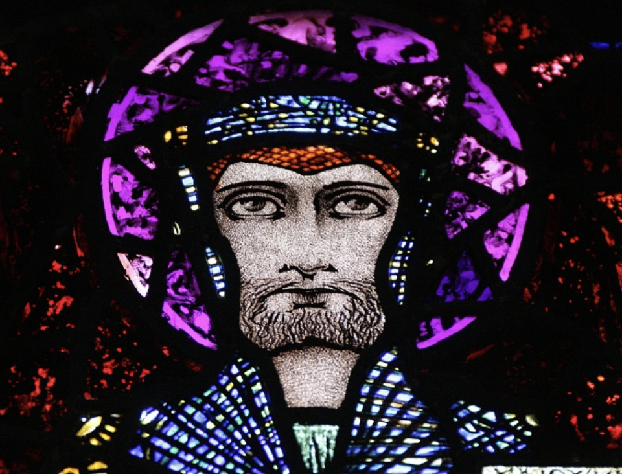

St Feichin of Fore, Pray for us
600-625-660 AD
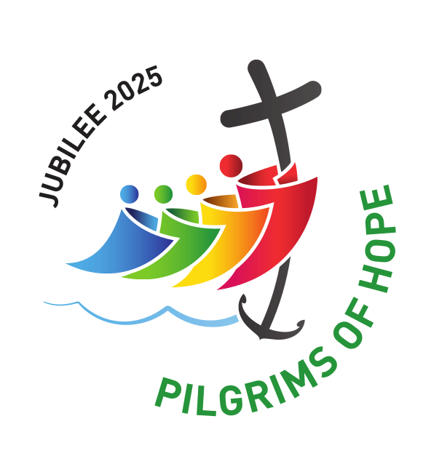

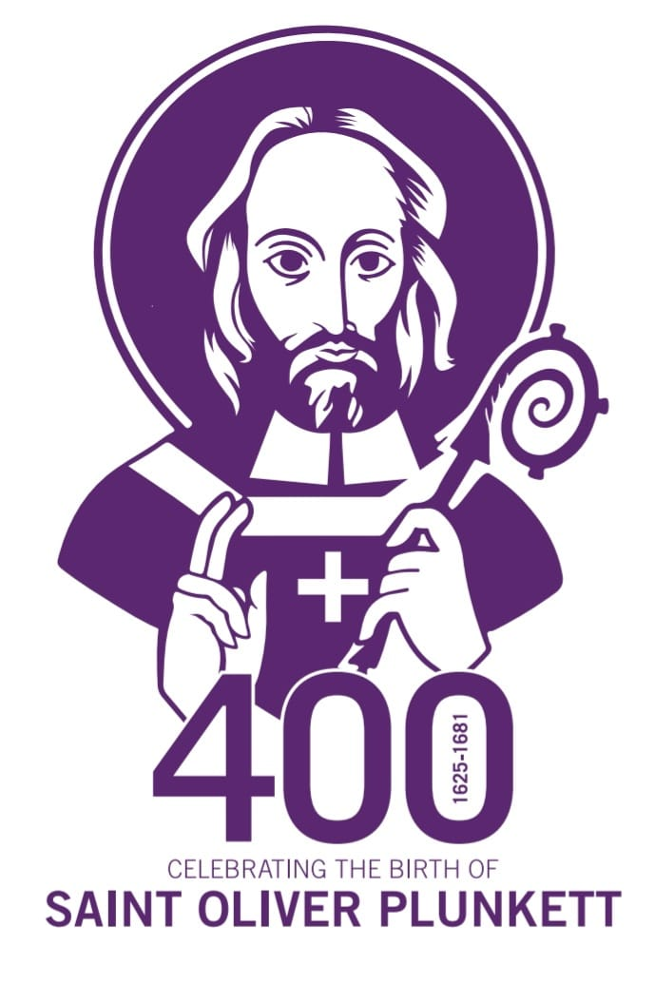

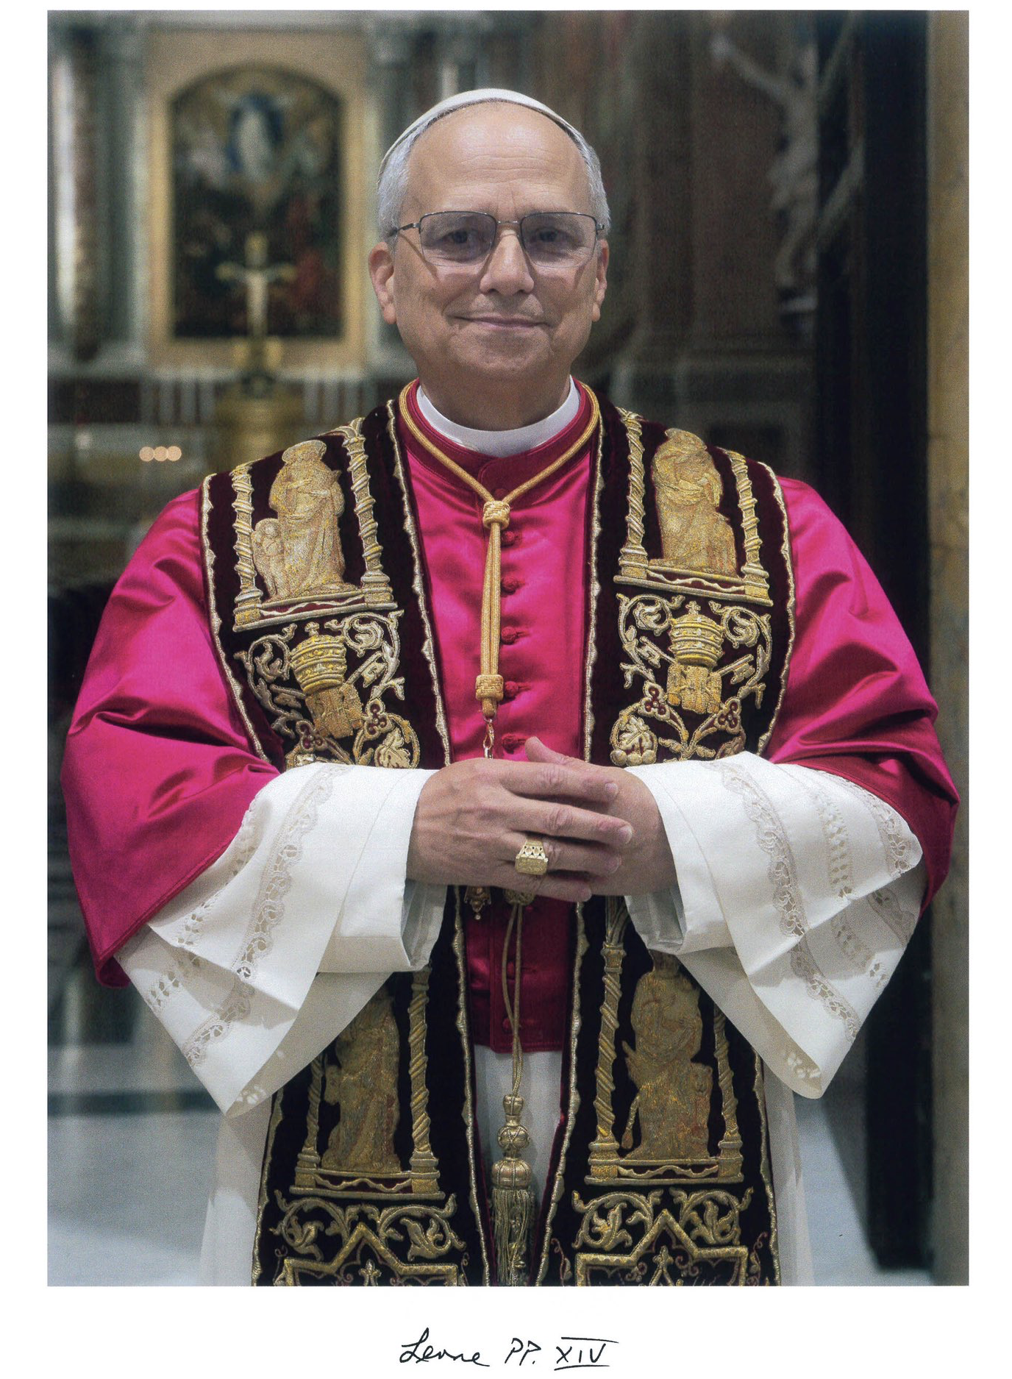

O God, shepherd and ruler of all the faithful,
look favourably on your servant Leo XIV,
whom you have set at the head of your Church as her shepherd;
grant, we pray, that by word and example
he may be of service to those over whom he presides
so that, together with the flock entrusted to his care,
he may come to everlasting life.
Through our Lord Jesus Christ, your Son,
who lives and reigns with you in the unity of the Holy Spirit,
God, for ever and ever. Amen.

Welcome to our Gathering
As we gather, as the 9 parishes of the Deanery of Fore, on the hallowed ground of the 13th Century Benedictine Monastery ruin and facing the 7th century foundation of the very apostolic St Feichin, opposite, we are overjoyed to be celebrating our parishes contribution to the Holy Year of Hope 2025 in our Deanery.
Our Celebration is absorbed into the greater celebrations in the Diocese especially in Oldcastle and Clonard churches and in the Christ the King Cathedral over the Jubilee Year. Conscious also that we are commenting St Oliver Plunkett’s 400th anniversary of birth and 50th anniversary of canonisation, native of Loughcrew, Oldcastle and our neighbour.
This current year we feel we are joined by St Feichin and St Oliver as we pray and gather in devotional loyalty to celebrate our Faith in Jesus Christ.
You are all very welcome today, especially our Bishop, the Benedictine monks of Silverstream Monastery, the Franciscan Sisters of the Renewal and our homilist today, Fr Barry White.
We hope and pray for a stronger witness of the Church in Ireland including all of us to the Faith in these secular times infringing on us. Pray too for our Holy Father Pope Leo and for all the Church leadership that they will be courageous, clear and timely in proclaiming the message of Jesus Christ in season and out of season, popular and unpopular, welcome or unwelcome. Also pray for world peace, which is so fragile and ask Mary, Queen of peace to enhance our sincere prayers. May our Holy year pilgrimage today enrich our personal spiritual lives and animate our parishes with vibrant Christians. May you all be blessed and return home safely with the power of the Risen Jesus enhancing all you have experienced.
Thank you,

Fr P Moore. PP, VF

Entrance procession & Gathering Hymn

1. Exposition of the Most Blessed Sacrament

O Salutaris Hostia,
Quae coeli Pandis ostium:
Bella premunt hostilia
Da robur, fer auxilium.

Uni trinoque Domino
Sit sempiterna gloria:
Qui vitam sine termino,
Nobis donet in patria. Amen.

2. Liturgy of the Word
3. Homily - Fr Barry White
4. Period of Silent Prayer
5. Rite of Benediction
Tantum ergo Sacramentum
Veneremur cernui;
Et antiquum documentum
Novo cedat ritui;
Praestet fides supplementum
Sensuum defectui.

Genitori, Genitoque
Laus et jubilatio,
Salus, honor, virtus quoque
Sit et benedictio:
Procendenti ab utroque
Compar sit laudatio. Amen.

Priest: Panem de caelo praetitisti eis.
People: Omne delectamentum in se habentem

Priest: Oremus.

Deus qui nobis sub Sacramento mirabili, passionis tuae memoriam reliquisti, tribue, quaesumus, ita nos corporis et sanguinis tui sacra mysteria venerari, ut redemptionis tuae fructum in nobis jugiter sentiamus. Qui vivis et regnas in saecula saeculorum.

People: Amen

+ The Blessing +

The Divine Praises
Blessed be God.
Blessed be his Holy Name.
Blessed be Jesus Christ, true God and true man.
Blessed be the name of Jesus.
Blessed be his most Sacred Heart.
Blessed be his most Precious Blood.
Blessed be Jesus in the most Holy Sacrament of the Altar.
Blessed be the Holy Spirit, the Paraclete.
Blessed be the great Mother of God, Mary most holy.
Blessed be her holy and Immaculate Conception.
Blessed be her glorious Assumption.
Blessed be the name of Mary, Virgin and Mother.
Blessed be Saint Joseph, her most chaste spouse.
Blessed be God in his angels and in his saints

6. Closing Hymn
&
We walk now to the Church for evening prayer

7. Evening Prayer in St Feichin’s Church Fore

O God, come to our aid.
O Lord, make haste to help us.
Glory be to the Father and to the Son
and to the Holy Spirit,
as it was in the beginning,
is now, and ever shall be,
world without end.
Amen. Alleluia.

Hymn
Holy God, we praise thy name;
Lord of all, we bow before thee!
All on earth thy sceptre own,
All in heaven above adore thee.
Infinite thy vast domain,
Everlasting is thy reign.

Hark! the loud celestial hymn,
Angel choirs above are raising;
Cherubim and seraphim,
In unceasing chorus praising,
Fill the heavens with sweet accord:
Holy, holy, holy, Lord.

Antiphon: Christ the Lord is a priest for ever according to the order of Melchizedek. Alleluia.
The Lord’s revelation to my Master:
‘Sit on my right:
your foes I will put beneath your feet.’

The Lord will wield from Sion
your sceptre of power:
rule in the midst of all your foes.

A prince from the day of your birth
on the holy mountains;
from the womb before the dawn I begot you.

The Lord has sworn an oath he will not change.
‘You are a priest for ever,
a priest like Melchizedek of old.’

The Master standing at your right hand
will shatter kings in the day of his wrath.
He shall drink from the stream by the wayside
and therefore he shall lift up his head.

Glory be to the Father and to the Son
and to the Holy Spirit,
as it was in the beginning,
is now, and ever shall be,
world without end.
Amen.

Antiphon: Christ the Lord is a priest for ever according to the order of Melchizedek. Alleluia.

Antiphon: Our God is in heaven; he has power to do whatever he will. Alleluia.

Not to us, Lord, not to us,
but to your name give the glory
for the sake of your love and your truth,
lest the heathen say: ‘Where is their God?’

But our God is in the heavens;
he does whatever he wills.
Their idols are silver and gold,
the work of human hands.

They have mouths but they cannot speak;
they have eyes but they cannot see;
they have ears but they cannot hear;
they have nostrils but they cannot smell.

With their hands they cannot feel;
with their feet they cannot walk.
(No sound comes from their throats.)
Their makers will come to be like them
and so will all who trust in them.

Sons of Israel, trust in the Lord;
he is their help and their shield.
Sons of Aaron, trust in the Lord;
he is their help and their shield.

You who fear him, trust in the Lord;
he is their help and their shield.
He remembers us, and he will bless us;
he will bless the sons of Israel.
(He will bless the sons of Aaron.)

The Lord will bless those who fear him,
the little no less than the great:
to you may the Lord grant increase,
to you and all your children.

May you be blessed by the Lord,
the maker of heaven and earth.
The heavens belong to the Lord
but the earth he has given to men.

The dead shall not praise the Lord,
nor those who go down into the silence.
But we who live bless the Lord
now and for ever. Amen.
Glory be to the Father and to the Son
and to the Holy Spirit,
as it was in the beginning,
is now, and ever shall be,
world without end.
Amen.

Antiphon: Our God is in heaven; he has power to do whatever he will. Alleluia.

Antiphon: Praise God, all you his servants, both great and small. Alleluia.

Alleluia.
Salvation and glory and power belong to our God,
his judgements are true and just.
Alleluia.

Alleluia.
Praise our God, all you his servants,
you who fear him, small and great.
Alleluia.

Alleluia.
The Lord our God, the Almighty, reigns,
let us rejoice and exult and give him the glory.
Alleluia.

Alleluia.
The marriage of the Lamb has come,
and his bride has made herself ready.
Alleluia.

Glory be to the Father and to the Son
and to the Holy Spirit,
as it was in the beginning,
is now, and ever shall be,
world without end.
Amen.

Antiphon: Praise God, all you his servants, both great and small. Alleluia.

Scripture Reading: 2 Thessalonians 2:13-14

We feel that we must be continually thanking God for you, brothers whom the Lord loves, because God chose you from the beginning to be saved by the sanctifying Spirit and by faith in the truth. Through the Good News that we brought he called you to this so that you should share the glory of our Lord Jesus Christ.

Short Responsory:

Great is our Lord; great is his might.
– Great is our Lord; great is his might.
His wisdom can never be measured.
– Great is our Lord; great is his might.
Glory be to the Father and to the Son and to the Holy Spirit.
– Great is our Lord; great is his might.

Antiphon: When you are invited to a marriage feast sit in the lowest place, so that the one who invited you can say to you, ‘Friend, take a higher place.’ Then everyone with you at table will see you honoured. Alleluia.

My soul glorifies the Lord,
my spirit rejoices in God, my Saviour.
He looks on his servant in her lowliness;
henceforth all ages will call me blessed.

The Almighty works marvels for me.
Holy his name!
His mercy is from age to age,
on those who fear him.

He puts forth his arm in strength
and scatters the proud-hearted.
He casts the mighty from their thrones
and raises the lowly.

He fills the starving with good things,
sends the rich away empty.

He protects Israel, his servant,
remembering his mercy,
the mercy promised to our fathers,
to Abraham and his sons for ever.

Glory be to the Father and to the Son
and to the Holy Spirit,
as it was in the beginning,
is now, and ever shall be,
world without end.
Amen.

Antiphon: When you are invited to a marriage feast sit in the lowest place, so that the one who invited you can say to you, ‘Friend, take a higher place.’ Then everyone with you at table will see you honoured. Alleluia.

Prayers and Intercessions:

Through the gospel, the Lord Jesus calls us to share in his glory. Let us make our prayer with him to our heavenly Father.

Response – Lord, in your mercy hear our prayer.

We pray for all nations:
that they may seek the way that leads to peace, that human rights and freedom may be everywhere respected, and that the world’s resources may be generously shared.
– Lord, in your mercy hear our prayer.

We pray for the Church:
that her leaders may be faithful ministers of your word, that all her members may be strong in faith and hope and that you may be recognised in the love she bears to all.
– Lord, in your mercy hear our prayer.

We pray for our families, and the community in which we live:
that we may find you in them.
– Lord, in your mercy hear our prayer.

We pray for ourselves:
that in the coming week we may serve others in our work and find peace when we rest.
– Lord, in your mercy hear our prayer.

We pray for the faithful departed:
that through your mercy they may rest in peace.
– Lord, in your mercy hear our prayer.

The Lord’s Prayer

Our Father…

Concluding Prayer:

Father of might and power,
every good and perfect gift
comes down to us from you.

Implant in our hearts the love of your name,
increase our zeal for your service,
nourish what is good in us
and tend it with watchful care.

Through our Lord Jesus Christ, your Son,
who lives and reigns with you in the unity of the Holy Spirit,
God, for ever and ever.
Amen.

The Lord bless us, and keep us from all evil, and bring us to everlasting life.

Amen.

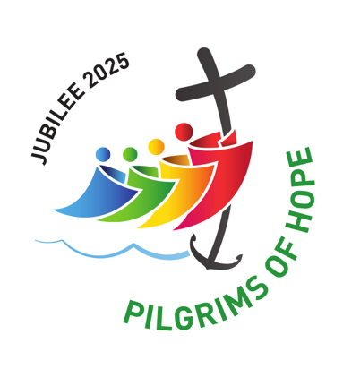

The Jubilee Prayer for the Holy Year 2025

Father in heaven,
may the faith you have given us
in your son, Jesus Christ, our brother,
and the flame of charity enkindled
in our hearts by the Holy Spirit,
reawaken in us the blessed hope
for the coming of your Kingdom.

May your grace transform us
into tireless cultivators of the seeds of the Gospel.
May those seeds transform from within both humanity and the whole cosmos
in the sure expectation
of a new heaven and a new earth,
when, with the powers of Evil vanquished,
your glory will shine eternally.

May the grace of the Jubilee
reawaken in us, Pilgrims of Hope,
a yearning for the treasures of heaven.
May that same grace spread
the joy and peace of our Redeemer
throughout the earth.
To you our God, eternally blessed,
be glory and praise for ever
Amen.

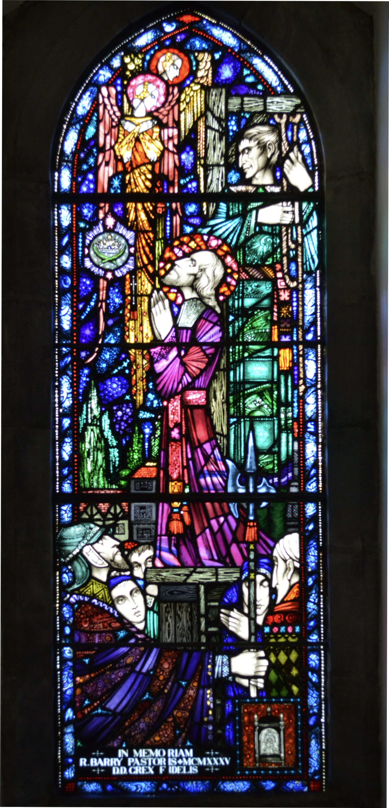

Glorious Martyr, Oliver, who willingly gave your life for your faith,
help us also to be strong in faith.
May we be loyal like you
to the See of Peter.
By your intercession and example may all hatred and bitterness
be banished from the hearts
of Irish men and women.
May the peace of Christ reign
in our hearts,
as it did in your heart,
even at the moment of your death. Pray for us and for Ireland. Amen.

A Jubilee Mass to mark the 400th anniversary
of the birth of Saint Oliver Plunkett
will take place in St Brigid & St Oliver’s Church, Oldcastle,
on Saturday 1st of November 2025 at 7pm
all are welcome

